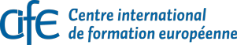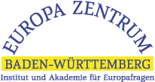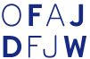
JEF Moldova
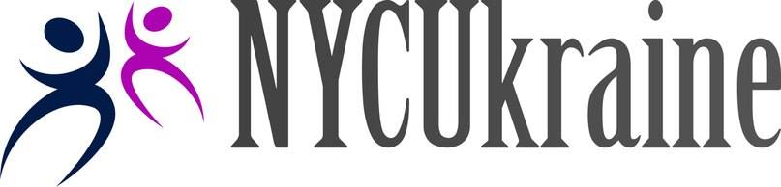

Application for HOW ABOUT CHANGE: Participation of Young People in Local and Regional Life in East and West
15. – 19.11. 2015 L’viv/Lemberg/Ukraine
1. – 5.12.2015 in Bad Liebenzell/Germany

Name, first name
Year of birth
Place of residence (incl. Country)

Nationality
Email
Mobile
Current Profession/Studies/fields of occupation
Which interests and/or experiences with participation do you have?

Past or current voluntary engagement

Please explain shortly your motivation to participate in the project:

Dietary requirements
(if any)

Other needs

I have noticed the dates and locations of the two seminars and am able and willing to participate in both seminars.

_________________________________ ________________________________
Date, place Signature

Please send back this form at the latest until 20 October 2015 to:
Europa Zentrum Baden-Württemberg
Ina Rubbert, Nadlerstr. 4, 70173 Stuttgart
Or via E-Mail: ina.rubbert@europa-zentrum.de

